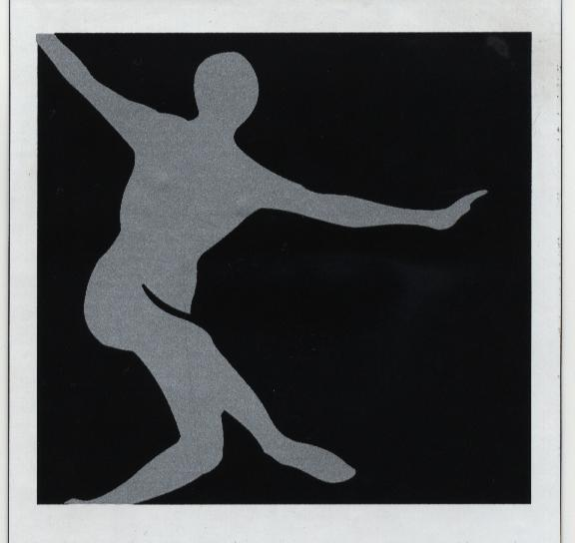 POSITIVE

IMAGE
PERFORMING

ARTS

2011 SUMMER FUN CAMP “DISCOVER DOWNTOWN”

2nd SESSION WEEK 5
MONDAY  AUGUST 8TH | TUESDAY  AUGUST 9TH | WEDNESDAY  AUGUST 10TH | THURSDAY  AUGUST 11TH | FRIDAY  AUGUST 11TH
7:30AM-9:00AM  GAMES & FREE PLAY | 7:30AM-8:15AM  GAMES & FREE PLAY | 7:30AM-8:15AM  GAMES & FREE PLAY | 7:30AM-8:15AM  GAMES & FREE PLAY | 7:30AM-8:15AM  GAMES & FREE PLAY
9:00AM-10:00AM  ENRICHMENT | 8:15AM-9:15AM  ENRICHMENT & CHANGE INTO DANCEWEAR | 8:15AM-9:15AM  ENRICHMENT | 8:15AM-9:15AM  ENRICHMENT & SNACK | 8:15AM-9:15AM  ENRICHMENT & SNACK
10:00AM-11:00AM  SNACK & CHANGE INTO DANCEWEAR | 9:15AM-10:30AM  SNACK | 9:15AM-10:30AM  SNACK | 9:15AM-10:30AM  CHANGE INTO DANCERWEAR, TAP & BALLET | 9:15AM-10:30AM  CHANGE INTO DANCERWEAR, TAP & LYRICAL
11:00AM-11:45PM  JAZZ & TAP | 10:30AM-3:30PM  SWIMMING @ KERNERSVILLE YMCA SWIM PARK | 10:30AM-11:00AM  MAKE UP MAKE OVERS & CHANGE IN TO DANCEWEAR | 10:30AM-11:00AM  ARTS & CRAFTS | 10:30AM-10:45AM  MANNERS & ETIQUETTE
NOON-12:45PM  ARTS & CRAFTS | CAMPERS NEED:  $6, SUNSCREEN, BAG LUNCH, 2 FROZEN WATER BOTTLES, 2 SNACKS, TOWEL, LOTION, CHANGE OF CLOTHES | 11:00AM-NOON  TECHNIQUE & CONDITIONING | 11:00PM-12:30PM  TOUR OF NISSEN BUILDING | 11:00 PM-3:30PM  LUNCH @ CHUCK E CHEESE  BRING $7  CAMPERS NEED TO WEAR ANY P.I.P.A. SHIRT & JEAN SHORTS
1:00PM-2:00PM  LUNCH |  | NOON-1:00PM  LUNCH | 12:30PM-1:30PM  LUNCH | CAMPERS WILL NEED  BUS PASS
2:00PM-3:30PM  MOVIE & CHANGE INTO DANCEWEAR |  | 1:00PM-2:00PM  SCOOTER BALL | 1:30PM-2:00PM  ARTS & CRAFTS
3:30PM-4:30PM  MODERN DANCE & CHEERLEADING |  | 2:00PM-3:30PM  MOVIE & CHANGE INTO DANCEWEAR | 2:00PM-3:30PM  MOVIE & CHANGE INTO DANCEWEAR
4:30PM-5:00PM  SNACK | 3:30PM-4:30PM  PRAISE DANCE & HIP HOP | 3:30PM-4:30PM  MODERN DANCE & CHEERLEADING | 3:30PM-4:30PM  PRAISE DANCE & HIP HOP
5:00PM-6:00PM  GAMES & FREE PLAY | 4:30PM-6:00PM  SNACK, GAMES & FREE PLAY | 4:30PM-6:00PM  SNACK, GAMES & FREE PLAY | 5:00PM-6:00PM  GAMES & FREE PLAY | 4:30PM-5:30PM  SNACK, GAMES & PREP FOR HOME

